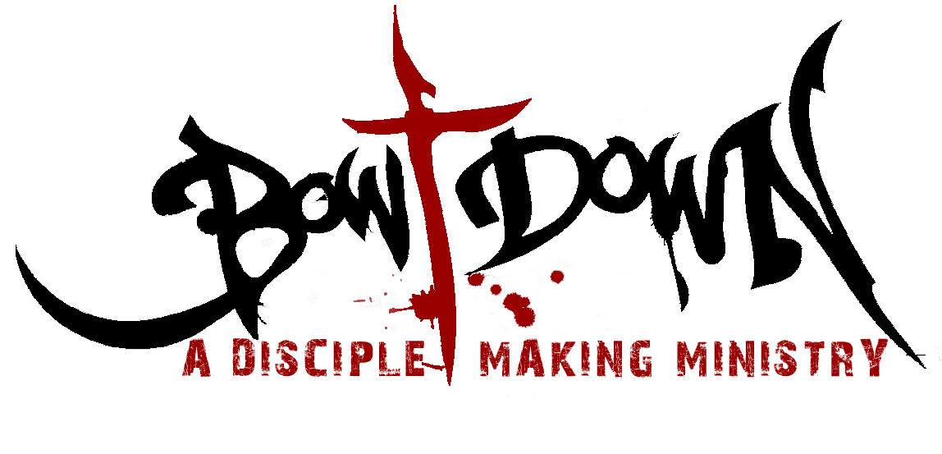
MENTORING APPLICATION
P.O. BOX 1630, West Palm Beach, FL 33402
Phone: 561-655-0935 Website: bowdownchurch.com

CONTACT INFORMATION:
Name: ____________________________________________________________
Address: __________________________________________________________
City, State, Zip: _____________________________________________________
Phone: ___________________________________ Do you text?
Emergency Contact Name: _______________________ Phone: ________________
Email: _________________________________________________
EDUCATION:
High School:
Did you graduate? ☐ Yes ☐ No
College (if applicable):
Did you graduate? ☐ Yes ☐ No
Major:
Are you currently a full-time student? ☐ Yes ☐ No
PRESENT OCCUPATION:
Employer:
Address:
Supervisor:
Phone:
Email:

REFERENCES:

Please include a reference from a church leader, and a reference from a friend, preferably a Christian, who has known you for more than one year.

CHURCH LEADER

Name:_________________________________________________

Phone:_________________________________________________

Relationship: ____________________________________________

Occupation: _____________________________________________

Personal Reference (non-family member)

Name:_________________________________________________

Phone: ________________________________________________

Relationship: ___________________________________________

Occupation: ____________________________________________

PLEASE ANSWER THE FOLLOWING QUESTIONS:
1. How did you hear about Bow Down Ministries?
2. What is your primary reason for wanting to serve with Bow Down?
3. In which areas do you want to serve?
4. Do you regularly attend a small group, Bible study, etc. in our church?
5. Are you willing to follow Bow Down’s policies even if you disagree with them? If not, please explain.
6. With which ministries have you been involved?
☐ Summer missions ☐ Evangelism events ☐ Bible studies ☐ Musical groups
☐ Other:
7. Have you previously served in the inner city in any way? If so, how?

8. How are you most encouraged?
☐ Encouraging words ☐ Quality time ☐ Acts of Service ☐ Gifts ☐ Other
To help us understand where you are in your walk with the Lord, please answer the following questions:

9. How did you come to know Jesus Christ as your Lord and Savior?
10. How do you define ministry?
11. What are your strengths and weaknesses?

12. How do you define a servant’s heart?

13. Is the Bible the infallible Word of God? Why or why not?

14. Take a few minutes to read and reflect on 1 Timothy 3. Do you believe you meet the requirements of a leader?

15. Are you currently being discipled by anyone? If so, please list their name, phone number, and e-mail address.
CONFIDENTIAL INFORMATION:
Please answer the following questions honestly. Your answers will not automatically disqualify you from being invited to volunteer at Bow Down.
1. Have you ever been arrested or convicted of a misdemeanor or felony? If so, please explain.
What was the charge?

Where (State/County/City)? Year?
2. Have you ever been formally accused of child abuse? If so, please explain.
3. Have you ever received psychiatric care? If so, please explain.
4. Have you ever struggled with addiction to illegal drugs or prescription medications? If so, please explain.
5. Do you consume alcohol? If so, in what situations and how often do you drink it?
VOLUNTEER WAIVER:
I understand and am affirming under oath to the truthfulness of the claims made herein and that the punishment for knowingly making a false statement includes fines and/or imprisonment. Under penalties of perjury, I declare that I have read the foregoing, and the facts alleged are true, to the best of my knowledge and belief.
Volunteer Signature: Date:__________

RELEASE OF CONTACT INFORMATION:
I understand that my phone number and email may be shared with other volunteers serving in the same ministry for replacement purposes if they need to find someone to switch weeks with them.

Volunteer Signature: Date: ___________
BACKGROUND CHECKS:
Please be advised that Bow Down reserves the right to perform county, state, and federal background checks on every volunteer. We take the protection of our children very seriously. Currently (2/23/11) in a 5-mile radius of our church, there are 274 registered sex offenders. Bow Down volunteers who have been background checked will receive a Bow Down t-shirt to wear while serving. Please DO NOT share your t-shirt with anyone!

The cost to process background checks is $15. If you can cover the cost of this, it would be very helpful to our church. However, if you financially cannot afford it, please let the mentor coordinator know. We do not want anything to keep you from serving.
☐ I have enclosed $15.00

DISCLOSURE AND AUTHORIZATION FOR EMPLOYER TO ACCESS CONSUMER REPORTS
Bow Down Church
PO Box 1630
West Palm Beach, FL 33402
AUTHORIZATION
I hereby authorize, without reservation, the obtaining of “consumer reports” or “investigative consumer” reports by Bow Down Church, Inc at any time after receipt of this authorization and throughout my employment or volunteer service, if applicable. I further authorize and request, without reservation, any present or former employer, school, police department, state or federal agency, financial institution, division of motor vehicles, consumer reporting agencies, or other persons or agencies having knowledge about me to furnish SecureSearch or Bow Down Church, Inc with any and all background information in their possession regarding me, so that my employment qualifications may be evaluated and/or reassessed. I also agree that a fax or photocopy of this authorization with my signature should have the same authority as the original.
By signing below, I certify: (1) that I have read and fully understand this disclosure and authorization; (2) that all of the information I am providing is true, complete, correct and accurate; and (3) that I have received the attached Summary of Your Rights under the Fair Credit Reporting Act (15 U.S.C. §1681 et seq.).
The following is information required in order for Bow Down Church, Inc to obtain a complete consumer report:

FULL LEGAL NAME (First, Full Middle Name, Last Name)
SOCIAL SECURITY NUMBER DATE OF BIRTH*
STREET ADDRESS
CITY, STATE, ZIP CODE
DRIVER’S LICENSE NUMBER ISSUING STATE
OTHER OR FORMER NAMES (AKA, Maiden Names, Married Names, Surnames, Etc.)
____________________________________________ ___________
VOLUNTEER’S SIGNATURE DATE
* This information will be used for background screening purposes only.
Please list all Counties and States you have lived in since the age of 18.
County State Name Used in County Date From Date To

________________________________________________________________________________________

______________________________________________________________________

_______________________________________________________________________________

_______________________________________________________________________________

DISCLOSURE

In connection with your application for employment or volunteer service with: Bow Down Church, Inc (including any independent contract for services) or when deciding whether to modify or continue your ongoing employment (if hired) or service, Bow Down Church, Inc may obtain a “consumer report” and/or an “investigative consumer report” on you from SecureSearch, a consumer reporting agency, or from any third party, in strict compliance with both state and federal law. A consumer report is a communication of information by a consumer reporting agency bearing on your credit worthiness, credit standing, credit capacity, character, general reputation, personal characteristics, or mode of living which is used or expected to be used for purposes of serving as a factor in establishing your current and/or continuing eligibility for employment purposes. An investigative consumer report is a report obtained through personal interviews with individuals who may have knowledge of your character, general reputation, personal characteristics, or mode of living. The consumer reports or investigative consumer reports may contain information regarding your credit history(if applicable to position), criminal records, driving history records, education records, previous employment history, social security traces, military records, professional licensure records, drug testing, government records, and other types of background information. You further understand that these reports may contain information concerning the reasons for termination of past employment. You are hereby notified that you have the right to make a timely request for the nature and scope of any investigative consumer report. You are further notified that, prior to being denied employment based in whole or in part on information obtained in the consumer report, you will be provided a copy of the report, the name, address and telephone number of the consumer reporting agency and a description in writing of your rights under the Fair Credit Reporting Act. Inquiries to SecureSearch should be directed to SecureSearch; Consumer Disputes; 558 Castle Pines Pkwy. #B4-137, Castle Rock, CO 80108. 1 (866) 891 – 1954.

The following are my responses to questions about my criminal record history (if any) with descriptions to any question with a YES answer:
Name:___________________________________________________________________________
- Have you ever been convicted or plead guilty before a court of any federal, state, or municipal criminal offense? (Excluding minor traffic violations) Yes ▢ No ▢ If Yes, please explain:

- Have you ever received deferred adjudication or similar disposition for any federal, state or municipal criminal offense? Yes ▢ No ▢ If Yes, please explain:

- Have you ever received probation or community supervision for any federal, state or municipal criminal offense? Yes ▢ No ▢ If Yes, please explain:

- Have you ever been convicted of any criminal offense in a country outside the jurisdiction of the United States? Yes ▢ No ▢ If Yes, please explain:

5. As of the date of this authorization, do you have any pending criminal charges against you? Yes ▢No If Yes, please explain:

6 .Have you ever served in the US Military? Yes ▢ No ▢

7. If you answered YES to the above question, did you receive a DD214? Yes ▢ No ▢
If Yes, can you present the document?: Yes ▢ No ▢

8. If you answered YES to the above question 6, did you receive an honorable discharge? Yes ▢ No ▢
If No, please explain:

Volunteer signature ____________________________________________ Date _______________

